Impact Pandemic on Tourism

Covid-19 has resulted in halting 50 million jobs across the globe, with Asia been the worst-hit region. After the outbreak is over, the tourism industry will take ten months to recover (World Economic Forum, 2020). Covid-19 has an adverse impact on the tourism industry with the potential of shrinking the travel sector up to 25 percent in 2020.
Covid-19 Impacts on Tourism Industry in Saudi Arabia
Due to the coronavirus, the tourism industry could be hit up to 45percent in 2020. As the country launched a new visa scheme for 49 nations, in 2019, the outbreak of Covid-19 caused the program to be closed in order to curb its spread. This resulted in borders closure for tourists from at least 25 countries. The impact of Covid-19 ranges from 35-45 percent decline in comparison to last year with the reliance on how the country reopens. The hotel industry has been impacted by will low occupancy ratio.

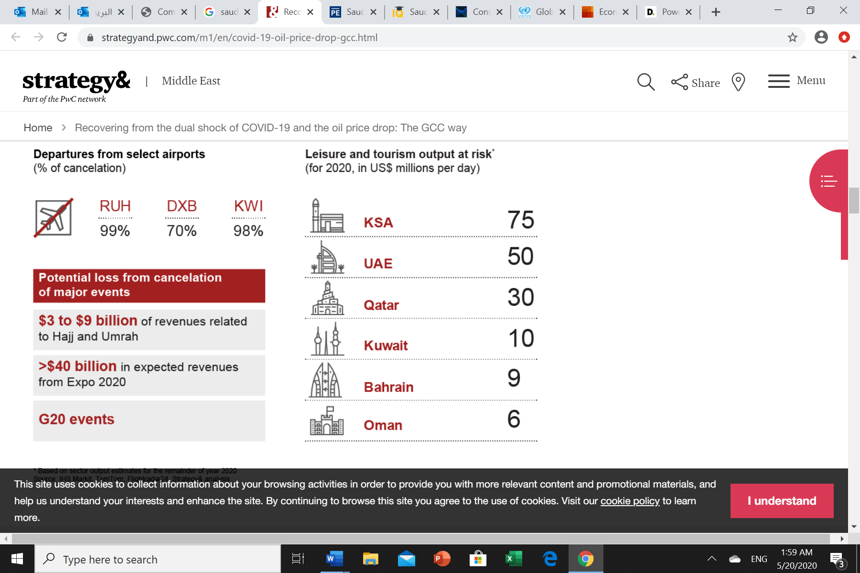
Conclusions
The primary objective is whether Saudi Arabia is able to survive the Covid-19 pandemic crisis. The nation has employed new strategies. The Minister of Finance claimed expenditure would be cut, and there will be a delay of the Kingdom's vision 2030 economic diversification strategy. Besides, the country is capable of borrowing with the objective of restoring the fiscal reserves. Despite the fact that there is a low-debt to GDP ratio of 24 percent, this indicates that there is the existence of contingency plans for the purpose of controlling and managing the crisis.
Besides, the country has oil reserves; this shows that is the economy begins to open, it will be the first beneficiary to supply its natural oil resources.
Implications
With regard to the trade-off between public health and economy, "free lunch" does not exist in an open and connected economy. Even with the pandemic, some nations have adopted NPIs to strengthen their economic spill. NPIs are likely to minimize the local demand and the demand for goods and services. NPIs have a likelihood of disrupting the supply chains, and this contributes to a generalized supply shock in an open economy.
The information flow among the locals signifies that the non-policies limit economic participation as well as labor supply, even in countries without the NPIs.
Recommendations
The country should be geared into stimulating the economy. Since supply and demand in the labor market have been affected, measures taken should include the provision of support for the workers as well as the enterprise in all the sectors in order to prevent any additional contractions in investment as well as consumption. The fiscal and monetary strategies should be used in supporting employment and social protection. Timely and coordinated fiscal and monetary policy implementation could prevent individuals and companies from encountering bankruptcies and facilitating sustainable recovery. The country should invest in the health and social sectors in order to expand the treatment and limit the rate of deaths. Besides additional fiscal resources should be implemented to support the health systems in the nation.

https://www.researchgate.net/publication/340771406_Tourism_The_Great_Patient_of_Coronavirus_COVID-2019
https://www.arabianbusiness.com/travel-hospitality/445714-saudis-tourism-industry-could-take-45-hit-due-to-covid-19
https://foreignpolicy.com/2020/05/05/2020-oil-crash-winner-saudi-arabia/
https://www.cdc.gov/nonpharmaceutical-interventions/index.html

